Science TEKS: 3.11, 4.6, 5.1, 5.2, 5.3, 5.4, 5.5
Math TEKS: 5.11, 5.14, 5.15 Name: _____KEY_________________
Lesson Four:
The Dual Nature of Ozone: Stratospheric Ozone
What does it mean that ozone is “Good up high, Bad nearby”?
Ozone up high in the stratosphere protects us from ultraviolet rays, but ozone at the surface can be breathed in by people and hurt our health.
Can you think of another example of something that is good to have in one place, but bad to have somewhere else?
Answers may vary, and include a lion (good at zoo, bad in living room), etc.
Overview. Ozone is a gas that is quite interesting because of its dual or “two-sided” nature. Ozone high up in the stratosphere naturally protects Earth from the Sun’s harmful ultraviolet light. However, ozone that forms close to the ground is a major air pollutant. This type of ozone can hurt humans and our surrounding environment.
Today, we will focus on the good ozone, which is called stratospheric ozone. You will learn a lot more about the “bad ozone” air pollution near the ground during Lesson Five.

Label the stratosphere, troposphere, and ozone layer in the diagram.
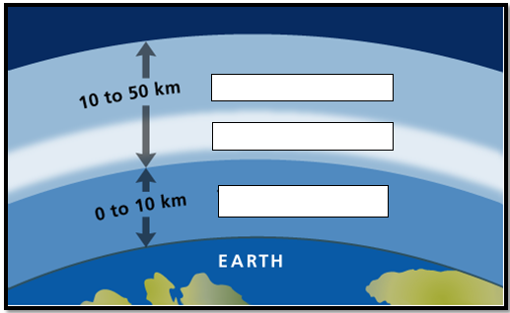

Stratosphere
Ozone layer
Troposphere

What did you learn about the ozone layer in the video?


How does the ozone layer protect life on Earth?
The ozone layer absorbs the Sun’s ultraviolet rays that can damage plants and animals.

What chemicals damage “good” stratospheric ozone?
Chlorofluorocarbons (CFCs) can damage stratospheric ozone.
What has been done to preserve the ozone layer?
The Montreal Protocol banned some of the CFCs and other gases that are most harmful to the ozone layer.

In the map that your teacher showed, where was the ozone hole?
Over Antarctica, during Southern Hemisphere springtime (October)

